**Project Report On**

**“DESIGN AND IMPELEMENTATION OF**

**ZOMATO DATA ANALYSIS”**

**SUBMITTED TO SAVITRIBAI PHULE PUNE UNIVERSITY**

**BACHELOR OF ENGINEERING**

**(Computer Engineering)**

**By**

|  |  |
| --- | --- |
| **SAYALI MALUSHTE**  **AISHWARYA MORE**  **SIMRAN RAUT**  **MEHAK NARGOTRA** | **Roll No:TCOB03**  **Roll No:TCOB05**  **Roll No:TCOB07**  **Roll No:TCOB10** |

**UNDER THE GUIDANCE OF**

**Prof. LAXMAN KHANDARE**



**Department of Computer Engineering**

**Dr.D.Y.Patil Institute of Technology Pimpri, Pune-18**

**2018-2019**



**Dr.D.Y.Patil Institute of Technology Pimpri, Pune-18**

**Department of Computer Engineering**

**CERTIFICATE**

This is to certify that the project entitled

“Design and Implementation of Zomato Data Analysis”

Submitted By

|  |  |
| --- | --- |
| Sayali Malushte  Aishwarya More  Simran Raut  Mehak Nargotra | Roll No:TCOB03  Roll No:TCOB05  Roll No:TCOB07  Roll No:TCOB10 |

Is a bonafide work carried out by them under the supervision of **Prof. Laxman Khandare** and it is approved for the partial fulfillment of the requirement of Savitribai Phule Pune University for the award of the Degree of Bachelor of Engineering (Computer Engineering).

Prof. Laxman Khandare Dr. Pramod. D. Patil

Internal Guide H.O.D

Dept. of Computer Engg. Dept. of Computer Engg.

Dr. S. N. Mali

Principal

Dr. D. Y. Patil Institute of Technology, Pimpri, Pune

**Signature of Internal Examiner Signature of External Examiner**

**CONTENTS**:

|  |  |  |
| --- | --- | --- |
| SR.NO | TITLE | PAGE NO. |
| **I.** | **INTRODUCTION** | **4** |
| **II.** | **OBJECTIVE** | **5** |
| **III.** | **REQUIREMENT ANALYSIS** | **6** |
| **IV.** | **DESIGN/PLANNING** | **7** |
| **V.** | **IMPLEMENTATION** | **8** |
| **VI.** | **SYSTEM REQUIREMENTS** | **11** |
| **VII.** | **TEST CASES** | **12** |
| **VIII.** | **MAINTENANCE** | **13** |
| **IX.** | **FUTURE SCOPE** | **13** |
| **X.** | **ADVANTAGES & DISADVANTAGES** | **14** |
| **XI.** | **CONCLUSION** | **15** |
| **XII.** | **REFRENCE** | **16** |





**ABSTRACT**

**Data analysis** is a process of inspecting, cleansing, transforming, and modeling data with the goal of discovering useful information, informing conclusions, and supporting decision-making. Data analysis has multiple facets and approaches, encompassing diverse techniques under a variety of names, while being used in different business, science, and social science domains.

A “Zomato Data Analysis” in Python is one of the most useful analysis for foodies who want to taste the best cuisines of every part of the world which lies in their budget.Therefore this analysis shows popular cuisines rating in US and in India.

1. **Introduction**

**Zomato** is an Indian restaurant search and discovery service founded in 2008 by Deepinder Goyal and Pankaj Chaddah. It currently operates in 24 countries. It provides information and reviews on restaurants, including images of menus where the restaurant does not have its own website.

In “Zomato Data Analysis” in Python, we have analyzed the highest and lowest restaurants in the cities of India by graph. Additionally, this analysis caters the needs of people who are striving to get the best cuisine of the country and which locality of that country serves that cuisines with maximum number of restaurants .Thus making it a very beneficial analysis result for the managers.

**Python** is an interpreted high-level programming language for general-purpose programming. In [computer programming](https://en.wikipedia.org/wiki/Computer_programming), **pandas** is a [software library](https://en.wikipedia.org/wiki/Software_library) written for the [Python programming language](https://en.wikipedia.org/wiki/Python_(programming_language)) for data manipulation and analysis.



**II.Objective**:

The objective of the project is to:

1. Provide Analysis based on true data.
2. Simplifying the work of the developer by reducing the time needed for analysis.
3. Providing analysis in form of Graphs, pie charts, bar charts.

**Hence we have performed the Analysis are:**

## Analysis I: Highest and lowest rated restaurants in the city (India)

To evaluate the Highest Rated and Lowest Rated Restaurant of the City in all the countries. Graph plotted only for countries with maximum restaurants(India)

## Analysis II: Popular cuisine of a country with location where it is served and number of restaurants serving that cuisine in that location

To evaluate the most popular cuisine of the world sold in a country and which locality in that country has most number of outlets selling that cuisine. Graph plotted only for the best cuisine of the country and the location where this cuisine is most popular with the count of places selling that cuisine.

## Analysis III: Value for money restaurants of U.S.A for the best cuisines

To evaluate the value for money restaurants in the U.S.A for the best cuisines served in the cities of U.S.A(value for money refers to the restaurants with highest rating and lowest cost)

**III. Requirement analysis**:

User requirements:

This Analysis will help you (user) to sort out the Highest and Lowest rated Restaurants around you and find out most popular cuisines.

**IV.Design / planning / modelling**:

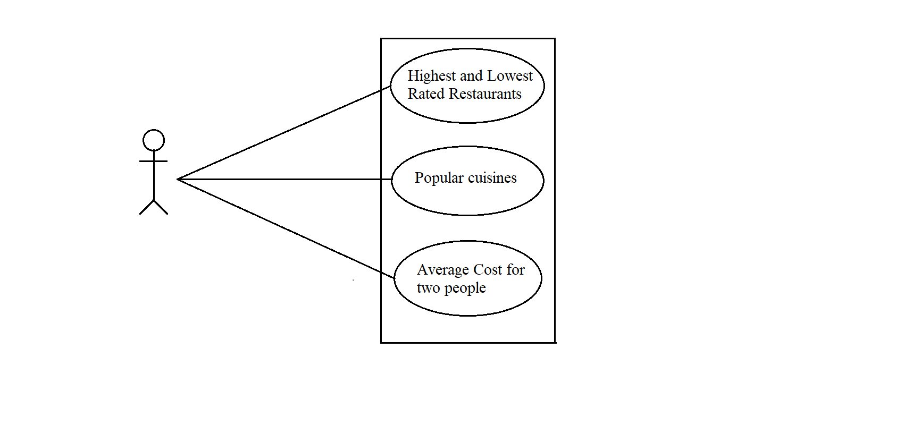USE CASE DIAGRAM FOR USER:

Fig 1

**V. Implementation:**

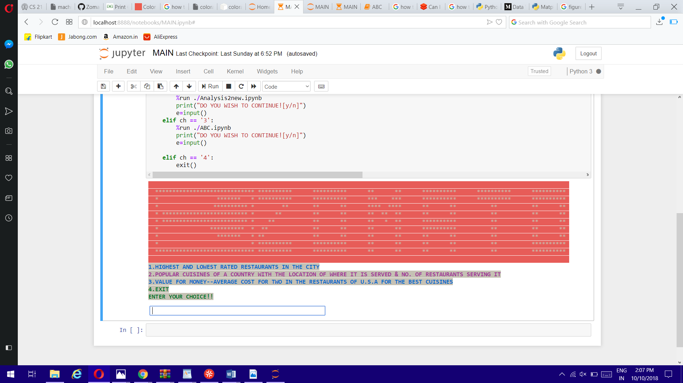**Snap shots of the project:**

**Fig. 1: MAIN PAGE**

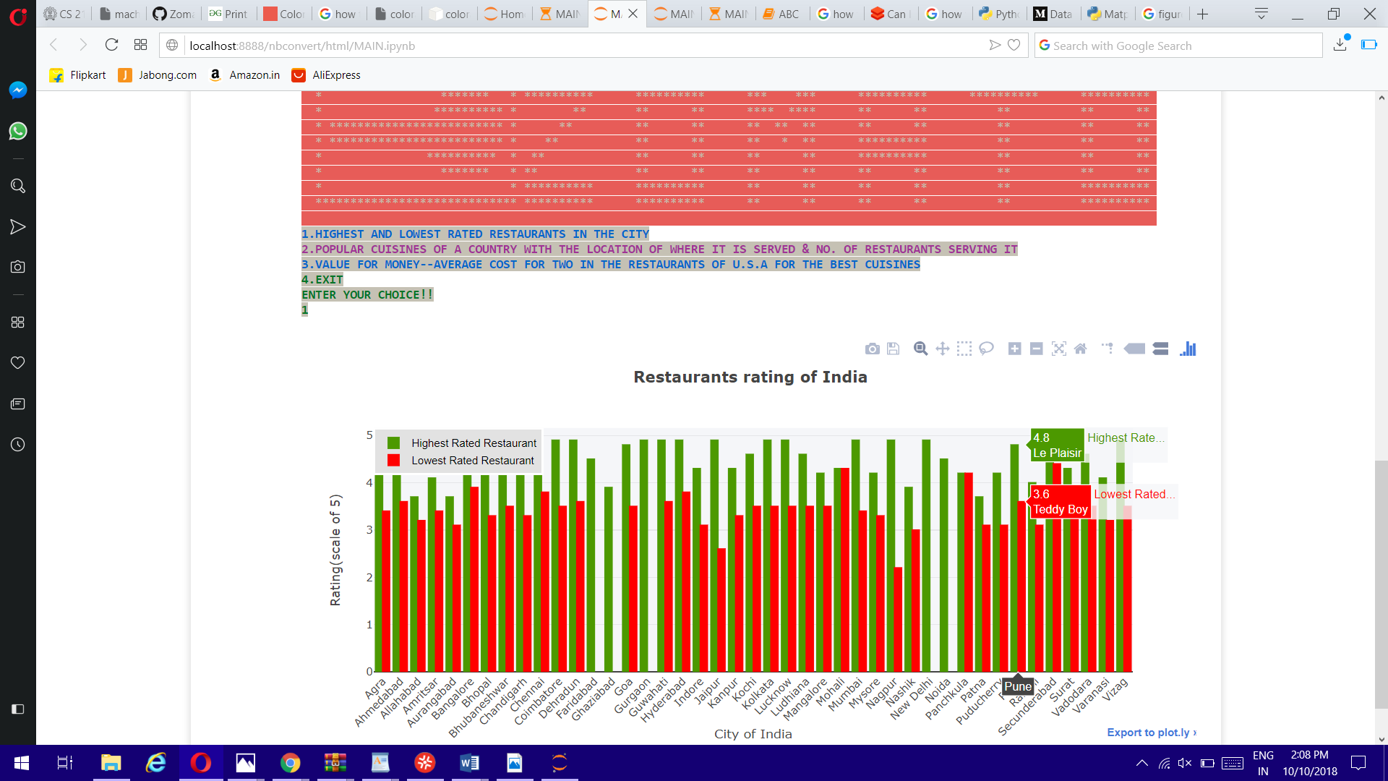

**Fig.2: Highest and Lowest Rated Restaurants**



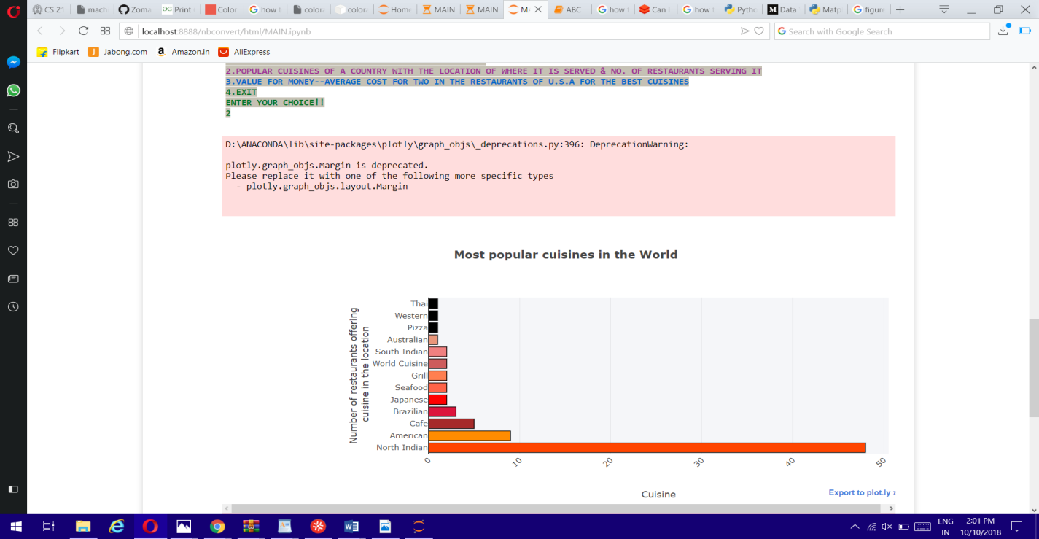**Fig. 3.1:Most Popular Cuisines in the World**

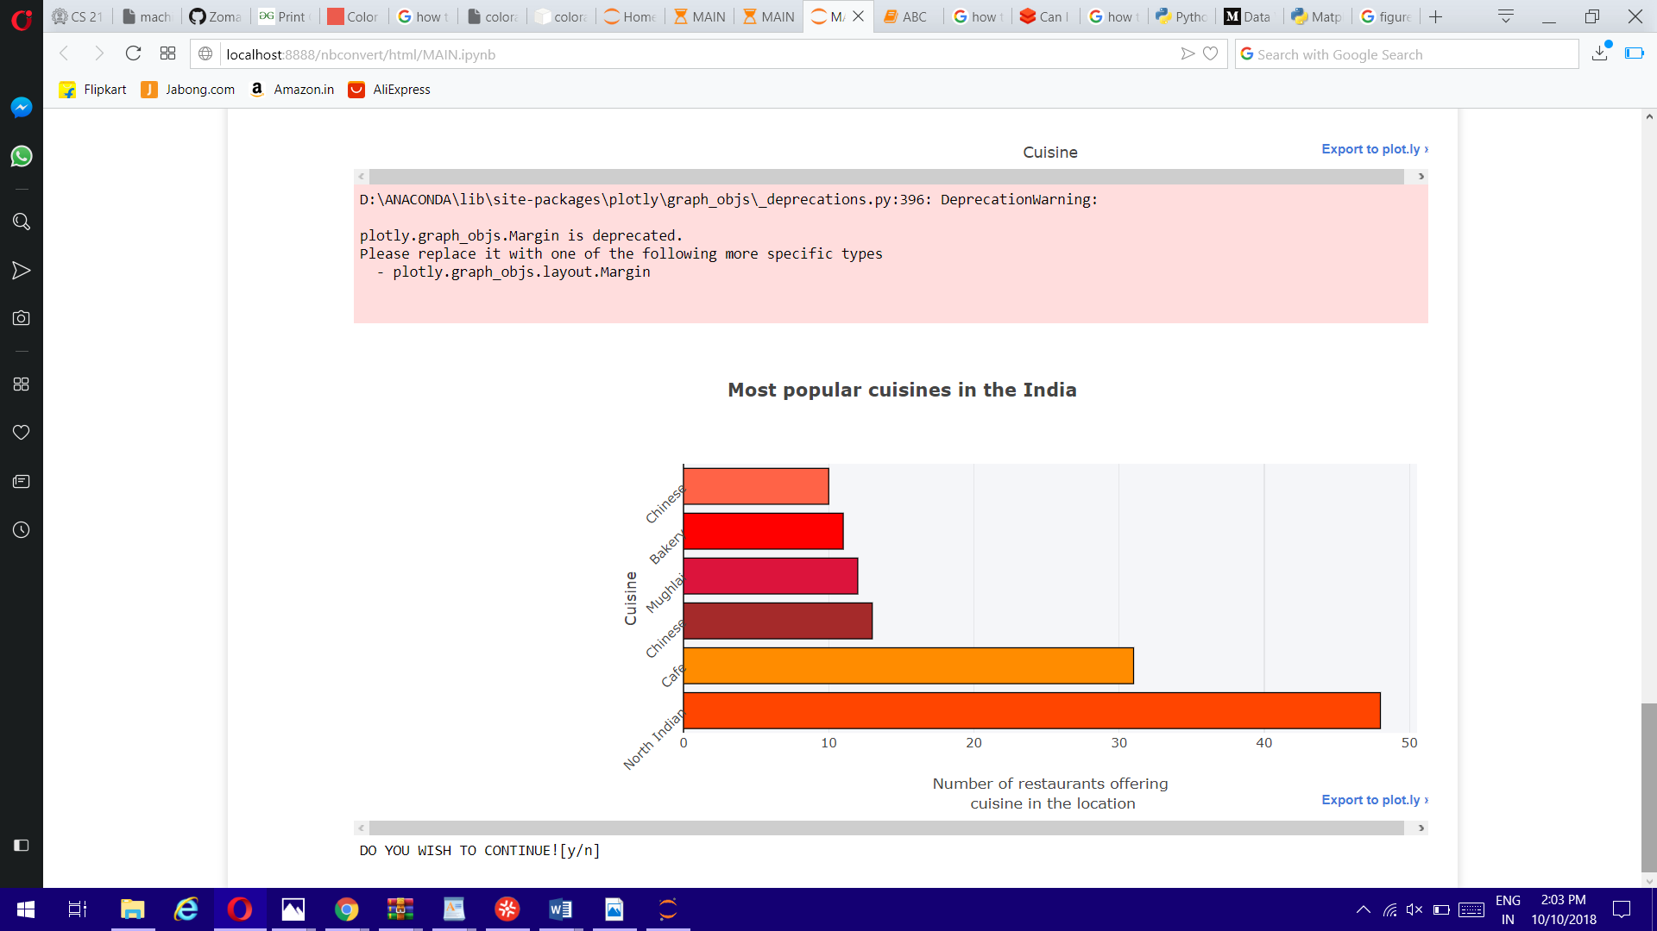

**Fig 3.2:Most Popular Cuisines in the Indi**

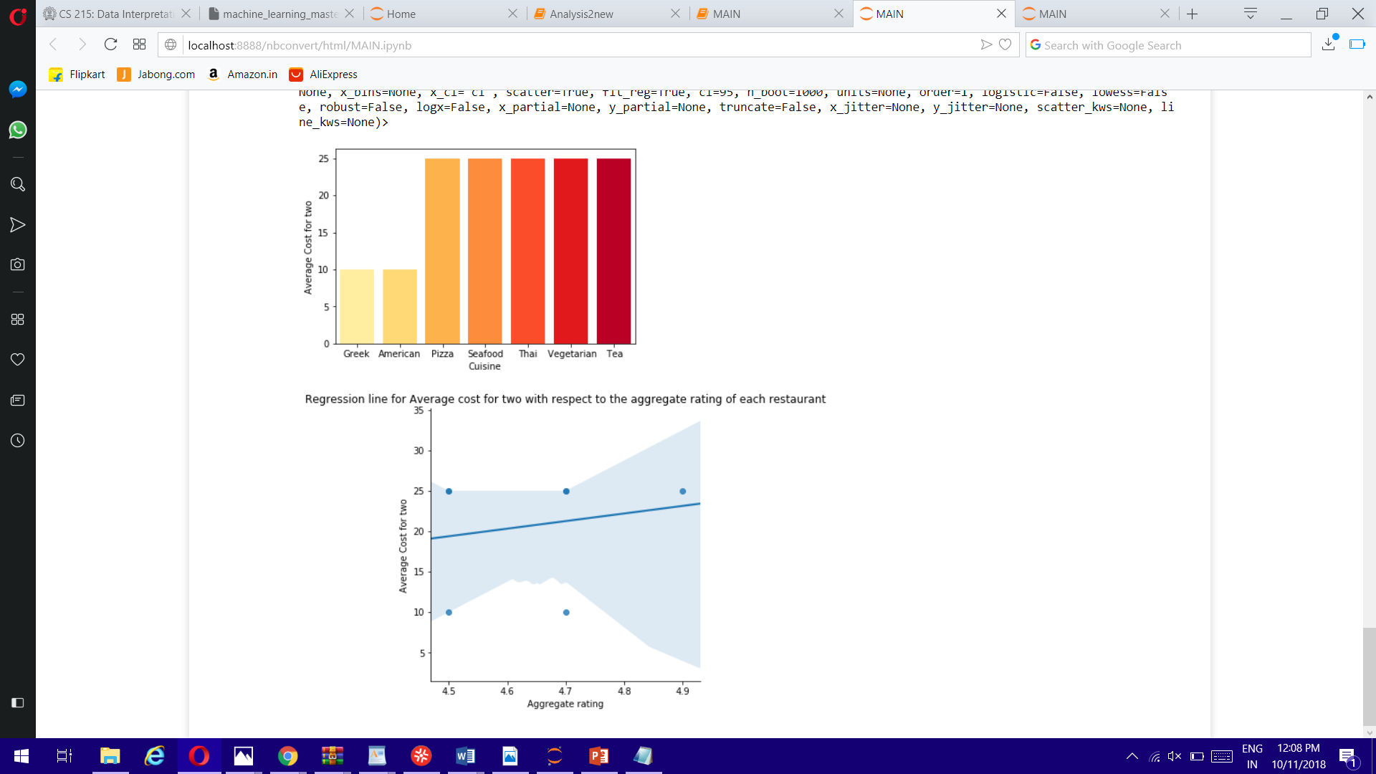**Fig 4:Average Cost For Two People**

**VI. System Requirement:**

* OPERATING SYSTEM:Microsoft **Windows 10**/8/7/Vista/2003/XP (incl.64-bit)
* 1024x768 **minimum** screen resolution.
* **Python** 3.6.X or higher
* Preferable IDE:Anaconda (as it provides most of the modules required for this analysis)

**HARDWARE REQUIREMENTS:**

* Processor : Intel® Core™ i3 processor or higher
* Hard disk: 1TB
* 1 GB RAM **minimum**.( 2 GB RAM recommended.)



**VII.Testing:**

|  |  |  |  |  |  |  |
| --- | --- | --- | --- | --- | --- | --- |
| |  | | --- | | Sr. No. | | Main Event | Input | Expected Result | Actual Result | Pass/Fail |
| 1. | Enter choice | 5 | Invalid choice | Invalid choice | Fail |
| 2. | Enter choice | 2 | Analysis 2 bar chart | Analysis 2 bar chart | Pass |
| 3. | Enter choice | @ | Invalid choice | Invalid choice | Fail |
| 4. | Do you wish to continue | y | Menu-Enter choice | Menu-Enter choice | Pass |
| 5. | Do you wish to continue | n | Exit | Exit | Pass |
| 6. | Do you wish to continue | Y | Invalid choice-Exit | Invalid choice-Exit | Fail |

**VIII. Maintenance**:

* Python needs to be updated to version 3 or more.
* Jupyter notebook
* Compatible tools: Microsoft Visual Studio*, PyCharm*



**IX. Future scope:**

1. With this project, state wise food analysis is also possible to get the information regarding states.

2. Project can be more user friendly by adding an User Interface, so that users can access it easily.

3. Any analysis can be performed further, if the dataset gets added.

**X. Advantages and Disadvantages:**

*Advantages:*

1) It is beneficial for the user who want to get information of best cuisine & food which is in their budget without going directly to restaurant.

2) It reduces efforts of user who want to find food locality of the particular country.

3) You can easily find out the high-rated and low-rated restaurant in a specific city or country.

*Disadvantages:*

1) It is must that user require to download anaconda and python tools in their system to work with this Zomato API system.

2) User must have knowledge of coding & functionality of anaconda & python programming to work with this system.



**XI. Conclusion**:

1) From the analysis1 above (graphs and csv), we can easily determine the highest and lowest rated restaurant of every city in the United States and India, depending upon which we may plan to choose our restaurant for the location we are at.

2) From the analysis2 above (graphs and csv), we can easily determine the cuisine we want to try and check which country is famous for that cuisine and which part of that country that world famous cuisine and how many restaurants in that location are serving that cuisine. This analysis will help us choosing the best location in that country for the most famous cuisine.

3) From the analysis3 above we can easily determine the value for money restaurants of the United States We definitely want to pay less and get the best quality food with best services, this analysis helps us determining the best value for money restaurant of U.S.A with the location.



**XII. Reference**:

* [www.tutorialspoint.com](http://www.stackoverflow.com/) -for pandas and numpy tutorial
* https://plot.ly -for plotly tutorial
* www.quora.com
* [www.youtube.com](http://www.youtube.com/)
* [www.simplifiedcoding.com](http://www.simplifiedcoding.com/)
* www.kaggle.com -for zomato dataset